Academy Compendium

September 2019

Contents
1.0 Ethos 3
2.0 Aims 3
3.0 Academy Characteristics 4
4.0 Academy Day 5
5.0 Academy Map 6
6.0 Governance Structure – Eastwood Park Academy Trust (EPAT) 7
7.0 Local Governing Body Structure 8
8.0 Leadership Structure 9
9.0 Pastoral Structure 11
10.0 Staff List 12
11.0 Academy Policies 16

1.0 Ethos

The Academy’s ethos ‘Believe, Succeed, Together’ is an uncompromising belief that all pupils can and will succeed in a learning community which supports and values everyone and their achievements.

2.0 Aims
- To provide a safe and secure environment in which all pupils are able to thrive.
- To provide an environment where pupils develop a strength of character, and resilience, that will help them to overcome the challenges they are likely to encounter in adult life.
- To provide an appropriate range of opportunities and experiences to allow pupils to succeed in the next stage in their education, training or employment.
- To provide an environment in which all pupils are able to develop as individuals and to broaden their horizons through a range of spiritual, moral, social and cultural opportunities.
- To provide a learning environment in which the majority of teaching is outstanding and never less than consistently good.
- To provide opportunities for all pupils to develop a high level of literacy and numeracy required for success in adult life.
- To provide a broad and balanced curriculum, including the opportunity for all pupils to achieve the ‘English Baccalaureate’ (EBacc).
- To provide opportunities for all pupils to achieve an attainment and progress score that exceeds expectations.
- To provide an environment in which every opportunity is taken to celebrate and share success.
- To provide an environment in which pupils feel proud of the Academy, shown by their excellent behaviour, attitude to learning, attendance and punctuality.

3.0 Academy Characteristics

The Eastwood Academy is an academy converter, established in August 2011. Its predecessor school held specialisms in Performing Arts, Sports and Mathematics and Computing.

In terms of substantive partnerships, the Academy is the Lead School in a multi-academy trust, Eastwood Park Academy Trust (EPAT), established in February 2017. It is also the hub school for the Southend West School Sports Partnership (SWSP) which provides services for 54 schools in the borough of Southend, and is a strategic partner in the South Essex Teaching School Alliance (SETSA).

The Academy is an average size secondary school with slightly more boys than girls. It is heavily oversubscribed, regularly receiving over 500 first and second preferences for 220 places.

On entry, pupils’ KS2 average fine points score is broadly in line with the national average.

Most pupils on roll are of White British heritage, with the % of pupils from minority ethnic groups below the national average. The proportion who speak English as an additional language is also below the national average.

The proportion of pupils known to be eligible for the Pupil Premium is broadly in line with the national average.

The proportion of pupils with SEN support and an EHCP is broadly in line with the national average.

Locally, the Academy is the highest performing non-selective school. Nationally, the Academy has been in the top quintile of schools over the last 3 years - DfE Performance Tables.

The Academy was subject to a section 5 inspection in December 2018 and achieved 'outstanding' in all categories - Ofsted Report 2018-2019

4.0 Academy Day

Period | Time
Morning Registration | 8.35 - 8.50
Period 1 | 8.50 - 9.55
Period 2 | 9.55 - 11.00
Break | 11.00 - 11.20
Period 3 | 11.20 - 12.25
Period 4 | 12.25 - 13.30
Lunch | 13.30 - 14.10
Period 5 | 14.10 - 15.15

The Academy operates a one week timetable covering 25 periods a week.

To maximise the amount and quality of learning time, each teaching period is 65 minutes in length and only one period is allocated after lunch.

Form time is 15 minutes per day from 8.35 – 8.50 a.m. Registration occurs during this time and pupils are expected to undertake literacy-based activities.

For each year group, one form period a week is allocated to an assembly – refer to the SMSC Assemblies Programme 2019-2020

5.0 Academy Map
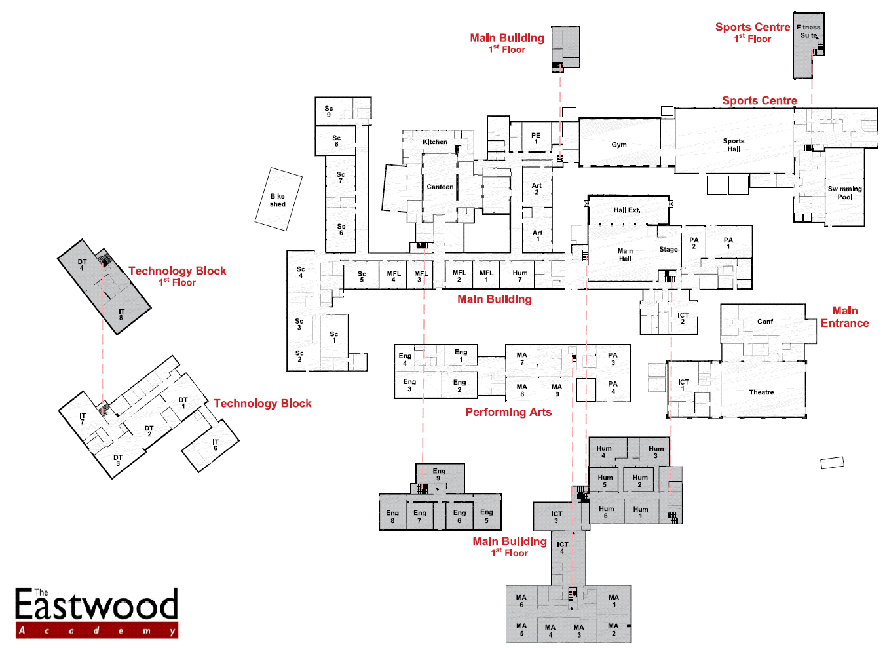

6.0 Governance Structure – Eastwood Park Academy Trust (EPAT)

Level of Governance | Number | Personnel | Meeting Frequency
Members | 3 | Stella Mirza, Dan Hagan and David Allen | Annually
Trustees (Board) | 6 | Adeela Fethi (Chair), Neil Houchen (CEO), David Allen, Ian Harke, Karen Heath and Mark Wilson | Termly
Finance and Audit Committee | 6 | Adeela Fethi (Chair), Neil Houchen (CEO), David Allen, Ian Harke, Karen Heath and Mark Wilson | Termly
LGB Committee | 11-13 | Principal (ex officio), 2 staff, 3 parents, 3-5 community-based. | Termly

7.0 Local Governing Body Structure

Level of Governance | Number | Personnel | Meeting Frequency
Local Governing Body | 11 | Ian Harke (Chair), Stephen Cummins (Vice Chair), Adeela Fethi, Neil Houchen, Frances Rodha, Lucas Abbott, Marina Gunn, Karen Heath, Darren Pike, Sharon Brooks and Kevin Buck | Termly

8.0 Leadership Structure

Level of Leadership | Number | Personnel | Meeting Frequency
Senior | 9 | Neil Houchen, David Piercy, Chris Niner, Mark Cartlidge, Pat Barrett, Scott Sterling, Yanik Moyet, Jodie Schmid and Louise Hodgson-Clark | Daily
Middle | 16 | Nick Dunn, Isabella Rossi, Sarah Stanley, Alison Steed, Craig Clark, Diana Furnival, Simon Watkins, Stuart Brown, Frances Rodha, Jo Edwards, Victoria Lang, Julie Haslett, Nicola Lillywhite, Nicola Niner and Nicola Hewitt | Weekly

Front row from left to right: Vice Principal, Mr. D. Piercy, Principal, Mr. N. Houchen, Vice Principal, Mr. C. Niner
Back row from left to right: Assistant Principal, Mr. P. Barrett, Assistant Principal, Mr. M. Cartlidge, Assistant Principal, Mr. S Sterling, Assistant Principal, Mrs. J. Schmid, Assistant Principal, Mrs. Hodgson-Clark, Assistant Principal, Mr. Y. Moyet

Pastoral Structure

 | Ashdown | Bowland | Elvedon | Kielder | Richmond | Sherwood | Whinfell
HOH | M Pearl | H Simm | J De’Ath | D Bracknell | S Wheeler | S Daltrey | D Braybrook
SLT | Y Moyet | P Barrett | L Hodgson-Clark | J Schmid | C Niner | M Cartlidge | D Piercy
7 | J. Lewis  Ma1 | S Zarrouki  Mfl2 | M Reynolds  Dt2 | M. Georgieva  Mfl3 | N Lawrence  Sc6 | R Casey  Ma9 | J Haslett  Mfl4
8 | Z William and  J Chambers  Mfl2 | L Guichard  Sc7 | H Walden  Art1 | L Abbot  IT7 | S Howard  En5 | S Harrison  Pa2 | N Lillywhite  Hu1
9 | S Stanley and  L Goodlad  Hu7 | N Dunn  IT6 | M Samir  Ma6 | N Amaewhule  Sc4 | V Otempong  Ma5 | B Salmon  Art2 | E Potts  Hu6
10 | A Bacon  En6 | L Keyes  Hu2 | I Rossi  Ma7 | F Rodha  Dt4 | N Hewitt  Pe1 | C Clark  Sc5 | V Lang  Hu4
11 | A Steed  En1 | S Watkins  Ma2 | L Childs  En2 | S Brown  Ma3 | K Danson  En9 | J Edwards  Hu5 | B Cooper  Ma8

Year 7 Catch-up Premium Intervention: D Kelsey and J Pearce
11P (Student Leadership Team): N Niner

10.0 Staff List

Title | Forename | Surname | Initial | Position | Subject

Senior Leadership Team
Mr. | Neil | Houchen | NH | Principal | Science
Mr. | Chris | Niner | CN | Vice Principal | Computing
Mr. | David | Piercy | DPi | Vice Principal | Mathematics
Mr. | Scott | Sterling | SS | Assistant Principal | P.E (SSP)
Mr. | Mark | Cartlidge | MC | Assistant Principal | Mathematics
Mr. | Pat | Barrett | PB | Assistant Principal | History and Citizenship
Mr. | Yanik | Moyet | YM | Assistant Principal | Science
Mrs. | Jodie | Schmid | JS | Assistant Principal | English and Drama
Mrs. | Louise | Hodgson-Clark | LHC | Assistant Principal | P.E and Business
Middle Leaders (Head of House)
Mr. | Mark | Pearl | MP | Head of Ashdown | English
Ms | Holly | Simm | HS | Head of Bowland | Science
Mrs. | Sophie | Daltrey | SSm | Head of Sherwood (Deputy DSL) | P.E and Science
Mr. | Jacob | De’Ath | JD | Head of Elvedon | P.E and Business
Mr. | Scott | Wheeler | SWh | Head of Richmond (First Aider) and 2nd in PE | P.E
Mr. | Daniel | Bracknell | DBr | Head of Kielder (First Aider) | P.E
Mr | Darren | Braybrook | DBr | Head of Whinfell (First Aider) | English
Middle Leaders (Head of Department)
Mrs. | Michelle | Arnold | MA | Head of Art | Art
Mrs. | Nicola | Niner | NN | Head of Business and Life Skills | Business and Life Skills
Mrs. | Joanne | Edwards | JE | Head of Citizenship/R.E/Sociology | Citizenship/R.E/Sociology
Mr. | Nick | Dunn | ND | Head of Computing and Careers | Computing and ICT
Ms | Isabella | Rossi | IR | Head of Drama | Drama
Mrs. | Alison | Steed | AS | Head of English | English
Mrs. | Frances | Rodha | FRo | Head of Food Technology | DT
Mrs. | Nicola | Lillywhite | NL | Head of Geography/PSHE/DofE (First Aider) | Citizenship/PSHE/Geography
Mr. | Martin | Reynolds | MRe | Head of Graphic Products | DT
Ms | Victoria | Lang | VL | Head of History | History and Citizenship
Mr. | Simon | Watkins | SW | Head of Mathematics | Mathematics
Mrs. | Julie | Haslett | JHa | Head of MFL | MFL
Mrs. | Sarah | Stanley | SS | Head of Music | Music
Mrs. | Nicola | Hewitt | NHe | Head of P.E | P.E
Mr. | Craig | Clark | CC | Head of Science (First Aider) | Science
Mrs. | Diana | Furnival | DFi | SENCO | Learning Support
Mr. | Stuart | Brown | SBr | Head of Statistics and PGCE/NQT Coordinator | Mathematics and Statistics
Teaching Staff
Mr. | Billy | Salmon | BSa | Art Department and SCITT Coordinator | Art and DT
Mr. | Lucas | Abbott | LAb | Computing Department | Computing and ICT
Mrs. | Deborah | Kelsey | DK | English Department | English
Mrs. | Lisa | Childs | LC | English Department | English
Mr. | Shane | Howard | SH | English Department | English
Ms | Annie | Bacon | AB | English Department | English
Mr. | Kevin | Danson | KD | English Department (NQT) | English
Ms | Emily | Potts | EP | Geography Department | Geography
Mr. | Liam | Keyes | LK | Humanities Department and MAP Coordinator | History, Citizenship and R.E
Mr. | Ralph | Casey | RCa | Mathematics | Mathematics
Mr. | Mohammed | Samir | MSa | KS3/KS4 Mathematics Coordinator | Mathematics
Mr. | Victor | Otempong | VO | Mathematics Department | Mathematics
Ms | Hannah | Walden | HW | Mathematics Department | Mathematics
Mr. | Ralph | Casey | RC | Mathematics Department | Mathematics
Mr. | Jay | Lewis | JL | Mathematics Department (NQT) | Mathematics
Mrs. | Judith | Chambers | JCh | MFL Department | MFL
Ms | Sarah | Zerrouki | SZ | MFL Department (NQT) | MFL
Mrs. | Mariya Nikolaeva | Georgieva | MNG | MFL Department (NQT) | MFL
Mrs. | Zoe | William | ZW | MFL Department | MFL
Mrs. | Angelina | Ashley-Chelton | AAC | MFL Department | MFL
Mr. | Sam | Harrison | SS | Music Department | Music
Ms | Jane | Pearce | JP | P.E and Food Technology Department | P.E and Food Technology
Ms | Bethany | Cooper | BC | P.E and Geography Department (NQT) | P.E and Geography
Mr. | Connor | Dare | CD | P.E, Science and Maths | P.E, Science and Maths
Mrs. | Elizabeth | Goodlad | EG | R.E and Citizenship Department | R.E and Citizenship
Ms | Lauren | Guichard | LG | KS4 Science Coordinator | Science
Ms | Ngozi | Amaewhule | NA | Science Department | Science
Mrs. | Natalie | Lawrence | NLa | KS3 Science Coordinator | Science
ITT Trainees
Ms | Catherine | Adams | KA | English Department | English
Ms | Lorine | Montagnard | LM | MFL Department | MFL
Ms | Laura | James | LJa | Science Department | Science
Ms | Elizabeth | Heath | EH | Science Department | Science
Mr. | James | North | JN | Humanities Department | History
Ms | Charlotte | Yarranton-Jones | CYJ | Humanities Department | History
Ms | Jessica | McGarva | JM | P.E | P.E
Tutors
Mrs. | Jo | Rasor | JRa | English Department | English
Mrs. | Lyanne | Austin | LAu | Mathematics Department | Mathematics
Mrs. | Rachel | Higgs | RHi | Mathematics Department | Mathematics
Support Staff
Mrs. | Laura | Rutter | LR | Attendance Support Officer and LAC Coordinator | Attendance/LAC
Ms | Michelle | Pacey | MPa | Cover Supervisor/Learning Support | All subject areas
Ms | Kym | Jones | KJ | Cover Supervisor/Learning Support | All subject areas
Ms | Olivia | Stead | OS | Cover Supervisor/Learning Support (First Aider) | All subject areas
Mr. | Spencer | Wilson | VSW | Attendance Support/Cover Supervisor | All subject areas
Mrs. | Deborah | Hughes | DH | Learning Support | All subject areas
Mrs. | Julie | Brown | JB | Learning Support | All subject areas
Mrs. | Carol | Bishop | CB | Learning Support | All subject areas
Ms | Moya | Cottridge | MCo | Learning Support | All subject areas
Mrs. | Jodie | Simms | JSi | Learning Support | All subject areas
Ms | Gerry | Cassidy | GC | Learning Support (First Aider) | All subject areas
Mrs. | Karen | Gilbert | KGi | Learning Support | All subject areas
Mrs. | Gill | Jones | GJ | Learning Support | All subject areas
Mrs. | Sharon | Freeman | SFr | TEA and EPAT Finance Officer | Finance
Mrs. | Madeline | Tomkins | MT | Deputy Finance Officer | Finance
Mrs. | Susan | Lynn | SLy | Senior Administrator and Principal’s P.A | Administration
Ms | Ruth | Hayward | RH | Examinations Officer | Examinations
Mrs. | Susan | Allen | SA | Senior Administrator | Administration
Mrs. | Paula | Matthews | PM | Senior Administrator | Administration
Mr. | Joseph | Gurney | JG | Reprographics Technician | Reprographics
Ms | Michelle | Philp | MPh | Senior Science Technician (Lead First Aider) | Science
Mr. | Shaiq | Sarwar | SSa | Science Technician | All subject areas
Mrs. | Lorraine | Randall | LRa | DT Technician | DT
Mr. | Carl | Wilks | CW | Network Systems Manager | ICT Support
Mr. | John | Chisnell | JCh | ITT Technician | ICT Support
Mrs. | Katie | Toms | KT | Trust Company Secretary | Administration

11.0 Academy Policies

Q1. Where can I access Academy policies?
The Academy’s policies can be accessed from two websites:
The Eastwood Academy - http://www.eastwoodacademy.co.uk/index.php/the-academy/academy-policies
Eastwood Park Academy Trust (EPAT) - http://www.epat.education/index.php/policies-and-statements

Q2. Are all policies current?
Yes. All policies are reviewed annually in June and published in July.

Q3. Which policies do I need to read/consult in respect to teaching and learning?
- Behaviour and Discipline Policy
- Curriculum Policy
- Celebrating Success Policy
- Equality Policy
- Homework Policy
- Literacy Policy
- Looked-after Children Policy
- Marking and Assessment Policy
- Most Able Pupils Policy
- Numeracy Policy
- SEND Policy
- SRE Policy
- Teaching and Learning Policy

Q4. Which policies do I need to read/consult in respect to behaviour management?
- Attendance Policy
- Behaviour and Discipline Policy
- Celebrating Success Policy
- E-Safety Policy
- Health and Safety Policy
- Mental Health Policy
- Supporting Pupils with Medical Conditions Policy

Q5. Which policies do I need to read/consult in respect to safeguarding?
- Attendance Policy
- Behaviour and Discipline Policy
- Code of Conduct (Staff) Policy
- E-Safety Policy
- Health and Safety Policy
- Keeping Children Safe in Education - September 2018 (Part 1)
- Mental Health Policy
- Safeguarding Policy
- Security Policy
- Severe Weather Policy
- Supporting Pupils with Medical Conditions Policy
- What to do if you are Worried a Child is being Abused
- Whistleblowing Policy

Q6. Which policies do I need to read/consult in respect to pay and performance?
- Pay Policy
- Performance Management Policy
- Capability Policy
- Probation Policy

Q7. Which policies do I need to read/consult in respect to absence?
- Leave of Absence Policy
- Sickness Absence Policy

Q8. Which policies do I need to read/consult in respect to my conduct and the conduct of my fellow employees?
- Code of Conduct (Staff) Policy
- Complaints Policy
- Disciplinary (Misconduct) Policy
- Grievance Policy
- Whistleblowing Policy

Q9. Which policies do I need to read/consult in respect to data protection?
- Data Protection Policy
- Records Retention Policy
- FOI Policy

Q10. If I am unclear on any policy detail, who do I ask?
In the first instance, refer any queries to your immediate line manager. If you remain unclear and/or dissatisfied with the response, you should seek clarity or further information from the Senior Leader attached to your area/department.

