Admissions - FAQ
1. How many places are available through the preferential admissions (school specialism) route?
10% of the Academy’s Published Admission Number (PAN) i.e. 20 places in total.
2. How do I apply for a preferential admissions (school specialism) place?
You must complete a Supplementary Information Form (SIF) and return it to the Academy by the 4th September 2017. SIFs received after this date, will not be considered.

3. Who do I send the completed SIF to?
The SIF is in a Word format so can be downloaded and e-mailed to the Coordinator for Admissions, Admissions@eastwood.southend.sch.uk or posted to: Admissions, The Eastwood Academy, Rayleigh Road, Leigh-on-Sea, Essex, SS9 5UU.
4. If I complete a SIF, do I still need to complete a Single Application Form (SAF)?
The SIF, in itself, is not an application form. You still need to complete a Single Application Form (SAF) which is accessed via the Southend Borough Council website – www.southend.gov.uk.

If you intend to apply for a preferential admissions (school specialism) place, you must click ‘yes’ in the relevant box on the SAF.

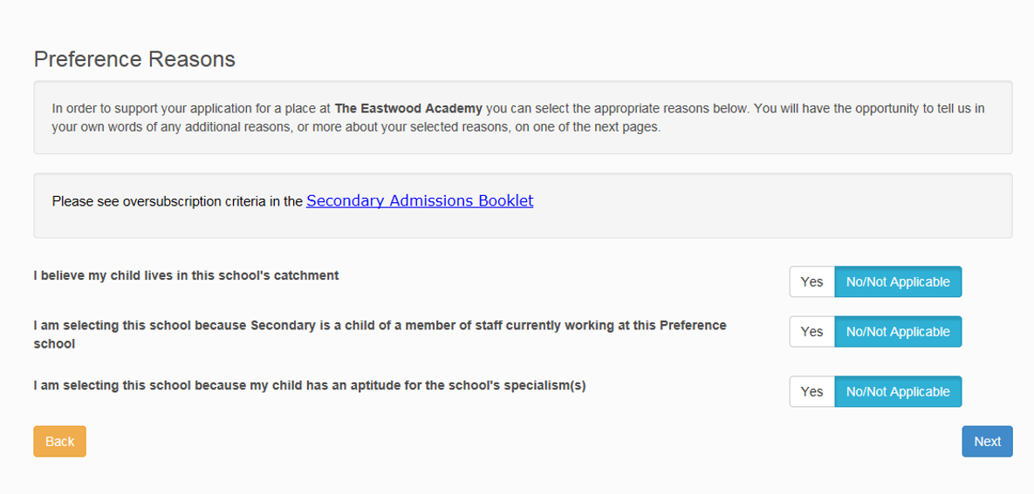

5. Can my child undertake aptitude tests for both P.E and Performing Arts?
Yes – the tests are held on different weeks – refer to Q9. Please note the Academy only offers preferential admission places for Physical Education/Sports and Performing Arts.
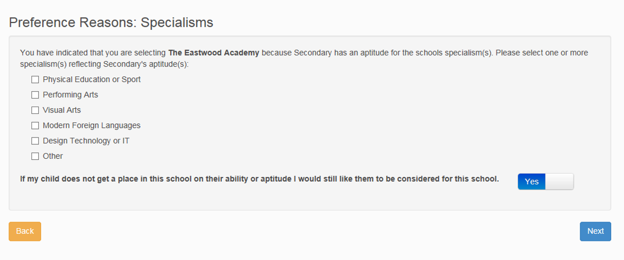
6. What do the tests entail?

Performing Arts

Candidates have an option of a theatre/vocal performance and/or a music/instrumental performance.
Theatre and Vocal Performance
Candidates will be expected to prepare a single 3 minute performance piece of their choice. It must comprise singing and/or acting, but may also involve a dance component e.g. a staged performance of a musical theatre solo; a performance of a script extract/monologue; or a solo song with backing track accompaniment.

Music – Instrumental Performance
Candidates will be expected to prepare a 3 minute piece of solo music on an instrument of their choice, with or without accompaniment. If an accompaniment is required, they may bring an accompanist to the audition or backing track on audio CD or an mp3 on a USB stick. The Academy will provide the following instruments/equipment: piano; electronic keyboard (61 keys); drum kit (please advise if left-handed); or guitar/bass amp. If a candidate plays an instrument requiring set up or tuning, they should arrive with sufficient time to do so before their audition.

Aptitude

The aptitude test is divided into 4 criteria of equal weighting. Candidates are awarded an aggregate score out of 100 which is converted into a ranked position.

Area | Performance | Accuracy | Expression | Communication
Mark | 25 | 25 | 25 | 25

Physical Education

Sports

The sports in which assessment is available are: Athletics, Swimming, Basketball, Football, Hockey and Netball.
Fitness

Fitness is assessed using a Bleep Test. This a multi-stage fitness test in which candidates must do shuttle runs in time with the bleeps until the bleeps get too quick to complete a full shuttle run. It is a maximal test which means it will take candidates to their fitness limit. The shuttle runs are done in time to bleep sounds on a pre-recorded device. The time between the recorded bleeps decreases every minute as the level goes up.

Aptitude

The aptitude test is divided into 3 criteria. Candidates are awarded an aggregate score out of 100 which is converted into a ranked position.

Area | Performance | Proficiency | Fitness
Mark | 30 | 30 | 40

7. Who is responsible for assessing the aptitude of candidates?
For standardisation purposes, two Academy staff will assess every candidate. Following discussion, a consensus will be reached regarding the aggregate score out 100.

For quality assurances purposes, a person independent of the Academy will assess the aptitude of a representative sample of candidates.

8. Can my child submit any supporting documents or other material as part of the aptitude test?
Candidates can provide any relevant documents or material in support of their aptitude test but they will not form part of the aggregate score out of 100.

9. What is the schedule/timetable for the aptitude tests?
Performing Arts

Week commencing 11th September 2017.
Physical Education
Week commencing 18th September 2017.

10. What if my child is ill or injured on the day of the aptitude test?
Please inform the Academy as soon as possible. An alternative date may be offered within the scheduled week (refer to Q9).

11. What if my child arrives late for the aptitude test?
All reasonable efforts should be made to attend on time.
12. How will my child be informed of his/her chance of obtaining a preferential admissions (school specialism) place?
Parents will be sent a letter in advance of 31st October.
The letter will include:
- An aggregate score out of 100 and the corresponding rank within the particular aptitude test(s).
- The candidate’s ranking in respect to the 20 places (Performing Arts and PE) available.
13. What is the historical chance of my child obtaining a preferential admissions (school specialism) place?
There are only 20* places available. Data from the last 4 years (below) shows the lowest ranking aptitude place of the pupil which secured a place through the Specialist School Place route.

Year | 2017 | 2016 | 2015 | 2014
Lowest Ranking Aptitude Place | 20th | 19th | 17th | 17th

*The number of places available has increased incrementally as a result of the PAN increasing from 168 -200.

14. My child received a ranking of 21st. What is their chance of obtaining a preferential admissions (school specialism) place?
There are only 20 places available through the preferential admissions route. If one of the pupils with a ranking of 1-20 declines a place, this becomes available to the pupil who is ranked 21st. Only pupils ranked from 1-20 can be sure of a place through the preferential admissions (school specialism) route.

