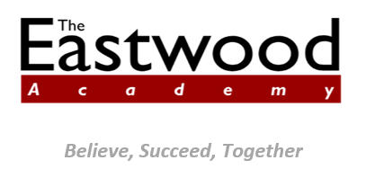

Dear Parent,

**Re: Changes to Free School Meal Eligibility Criteria under Universal Credit**

The eligibility criteria for free school meals has recently changed. This letter explains the changes and how they might affect you.

**What are the new eligibility criteria?**

Children are entitled to receive free school meals if they or their parents receive any of the benefits below.

* Universal Credit, provided they have an annual net earned income not exceeding £7,400 (£616.67 per month).
* Income Support.
* Income-based Jobseeker’s Allowance.
* Income-related Employment and Support Allowance.
* Support under Part 6 of the Immigration and Asylum Act 1999.
* The guarantee element of Pension Credit.
* Child Tax Credit, provided they are not also entitled to Working Tax Credit and have an annual gross income of no more than £16,190, as assessed by HMRC.
* Working Tax Credit run-on – paid for 4 weeks after you stop qualifying for Working Tax Credit.

**I don’t currently claim free school meals – what does this mean for me?**

If you think you might be eligible for free school meals, submit a claim to the Academy or Southend Borough Council.

The information you provide will be used to check if you are in receipt of a qualifying benefit and, if you are on Universal Credit, that your earnings do not exceed the threshold. If you claim Universal Credit, your earnings will be assessed from up to three of your last Universal Credit assessment periods.

If you are eligible, your school will be notified. Your child will receive free school meals and the Academy will receive extra funding.

**I am currently claiming free school meals – what does this mean for me?**

Most people will not be affected by the new criteria. If you are currently claiming free school meals, but do not meet the new criteria, your child will continue to receive free school meals until the end of the Universal Credit rollout period. This will apply even if your earnings rise above the new threshold or if you stop being entitled to Universal Credit. The rollout period is currently scheduled to end in the summer of 2023.

Once Universal Credit is fully rolled out, your child will keep their free school meal until the end of their current phase of education i.e. secondary.

**Where can I get more information?**

If you need any further information, please contact Mrs. S. Lynn – [Slynn@eastwod.southend.sch.uk](mailto:Slynn@eastwod.southend.sch.uk).

You can also visit the free school meal website: <https://www.gov.uk/apply-free-school-meals>

Yours sincerely,

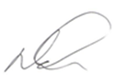

Mr. N. Houchen

Principal